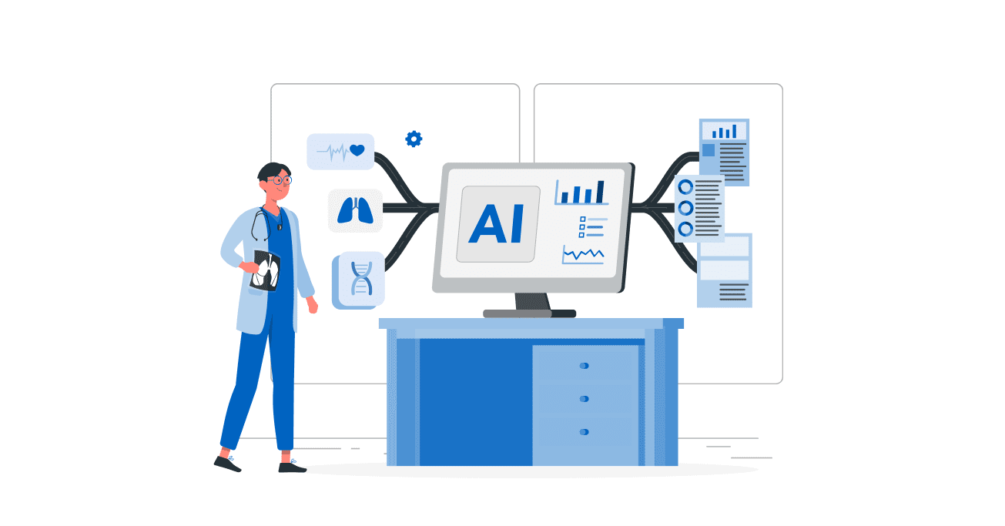

**Maroun Semaan Faculty of Engineering and Architecture**

**American University of Beirut**



DeepMed Documentation Report

Titles: Amasis MT Pro Black (11)

Content: Calibri (10)

**Table of Contents:**

1. **Introduction**

* Background and Motivation
* Project Overview
* Purpose and Scope
* Target Audience
* Key Features

1. **System Architecture**

* High-Level Architecture
* Technology Stack
* Component Diagram
* Data Flow

1. **Installation and Setup**

* Prerequisites
* Environment Setup
* Database Configuration
* Dependencies Installation
* Environment Variables

1. **User Guide**

* Getting Started
* User Interface Overview
* Step-by-Step Workflows
* Common Use Cases
* Troubleshooting

1. **Technical Documentation**

* API Documentation
* Database Schema
* Model Architecture
* Authentication System
* Security Measures

1. **Development Guide**

* Development Environment Setup
* Code Structure
* Coding Standards
* Testing Procedures
* Deployment Process

1. **Maintenance and Operations**

* Monitoring
* Backup Procedures
* Performance Optimization
* Security Updates
* Scaling Guidelines

1. **Appendix**

* Glossary
* FAQ
* Error Codes
* Reference Materials

**1.Introduction**

* 1. **Background and Motivation**

The healthcare sector faces unprecedented challenges in delivering high-quality patient care while managing increasing complexity and data volume. Medical professionals are often overwhelmed by the sheer amount of patient data, research findings, and clinical guidelines they need to process daily. Traditional healthcare systems and manual analysis methods struggle to keep pace with the growing demands of modern medicine, leading to potential delays in diagnosis, treatment inefficiencies, and missed opportunities for preventive care.

The COVID-19 pandemic has further highlighted the critical need for intelligent, data-driven healthcare solutions. Healthcare providers found themselves grappling with rapidly changing protocols, emerging research, and the need to make quick, informed decisions under pressure. This crisis underscored the importance of having tools that can quickly analyze medical data, identify patterns, and provide evidence-based recommendations to support clinical decision-making.

Moreover, the healthcare industry is experiencing significant transformation driven by technological advances and the increasing availability of medical data. However, many healthcare organizations lack the technical expertise or resources to fully leverage this data for improving patient care. The gap between available medical data and actionable healthcare insights continues to widen, creating a pressing need for solutions that can bridge this divide.

Recognizing these challenges, our team developed DeepMed—an AI-powered medical platform designed to transform how healthcare professionals interact with and utilize medical data. By combining cutting-edge artificial intelligence with user-friendly interfaces, DeepMed aims to empower healthcare providers with intelligent tools that enhance their decision-making process, improve patient outcomes, and streamline healthcare delivery. The motivation behind DeepMed stems from three core observations:

1. Data Overload: Healthcare professionals are drowning in data but starving for insights. They need tools that can efficiently process and analyze medical information to extract meaningful patterns and recommendations.
2. Time Pressure: Medical staff often lack the time to thoroughly analyze patient data or stay updated with the latest medical research. There's a critical need for automated systems that can provide quick, reliable insights.
3. Accessibility Gap: Many powerful medical AI tools exist but remain inaccessible to the average healthcare professional due to their complexity or technical requirements. There's a need for solutions that bring advanced medical AI capabilities to the fingertips of healthcare providers.
   1. Project Overview:

DeepMed is a user-friendly medical AI platform that helps healthcare professionals make better decisions using artificial intelligence. Think of it as an intelligent assistant that can analyze medical data, spot patterns, and provide helpful insights to improve patient care. The platform is designed to be intuitive and accessible, whether you're a medical professional looking to enhance your decision-making process or a researcher working on healthcare projects.

DeepMed combines the power of artificial intelligence with medical expertise to create a comprehensive healthcare solution. It's like having a team of data scientists and medical experts working together to help you make better healthcare decisions. The platform can handle everything from simple tabular patient data analysis to complex imaging, making it an invaluable tool for modern healthcare delivery.

What sets DeepMed apart is its focus on simplicity and effectiveness. While other medical AI platforms might be complex and require extensive technical knowledge, DeepMed is designed to be as straightforward as dragging and dropping the data. Healthcare professionals can focus on what they do best - caring for patients - while the platform handles the complex data analysis behind the scenes.

The platform is built on cutting-edge technology but presented in a way that feels natural and familiar to healthcare professionals. Whether you're a doctor looking to improve patient outcomes, a nurse tracking patient progress, or a researcher analyzing medical data, DeepMed adapts to your needs. It's not just another medical software tool; it's your intelligent partner in healthcare delivery.

DeepMed understands that every healthcare professional has unique needs and varying levels of technical expertise. That's why it offers a flexible interface that can be as simple or as advanced as you need it to be. For those who want to dive deep into data, the platform provides extensive analysis documentation and explainability. For those who prefer a more straightforward approach, it offers clear, actionable insights without technical complexity.

The platform is continuously evolving, incorporating the latest advances in medical AI and healthcare technology. It's designed to grow with your needs, whether you're working in a small clinic or a large hospital system. With DeepMed, you're not just using a tool; you're joining a community of healthcare professionals who are transforming healthcare delivery through intelligent technology.

* 1. **Purpose and Scope:**

DeepMed aims to transform healthcare delivery by making advanced medical AI accessible to healthcare professionals at all levels. Our platform serves as a bridge between complex medical data and actionable healthcare insights, addressing critical challenges in modern healthcare:

* + 1. **Improving Patient Outcomes**
* Early Detection: Help identify potential health issues before they become critical
* Personalized Care: Enable tailored treatment plans based on individual patient data
* Risk Assessment: Provide accurate predictions about patient health risks
* Treatment Optimization: Suggest the most effective treatment approaches based on historical data
  + 1. **Supporting Healthcare Professionals**
* Decision Support: Offer data-driven insights to support clinical decisions
* Time Efficiency: Automate routine data analysis tasks, allowing more time for patient care
* Knowledge Enhancement: Provide AI-powered medical insights and recommendations
* Research Support: Facilitate medical research through automated analysis tools
  + 1. **Advancing Healthcare Quality**
* Standardization: Help maintain consistent quality of care across different settings
* Evidence-Based Practice: Enable data-driven healthcare decisions
* Quality Monitoring: Track and analyze healthcare outcomes
* Continuous Improvement: Support ongoing healthcare quality enhancement
  + 1. **Promoting Healthcare Innovation**
* Research Acceleration: Speed up medical research through automated analysis
* Pattern Discovery: Help identify new medical patterns and correlations
* Treatment Innovation: Support the development of new treatment approaches
* Healthcare Trends: Enable better understanding of healthcare patterns and outcomes
  + 1. **Ensuring Healthcare Accessibility**
* Resource Optimization: Help healthcare providers work more efficiently
* Cost Reduction: Support cost-effective healthcare delivery
* Scalability: Enable healthcare services to reach more patients
* Quality at Scale: Maintain high-quality care even with increased patient loads
  + 1. **Supporting Healthcare Organizations**
* Operational Efficiency: Streamline healthcare operations
* Resource Planning: Help with better resource allocation
* Performance Tracking: Monitor and improve healthcare service delivery
* Compliance Support: Assist in maintaining healthcare standards and regulations
  + 1. **Fostering Medical Education**
* Training Support: Provide tools for medical education and training
* Knowledge Sharing: Enable better sharing of medical insights
* Case Analysis: Support analysis of medical cases for learning
* Best Practices: Help disseminate medical practices
  1. **Target Audience**

DeepMed is designed for anyone working in healthcare who wants to use data to improve their work:

* + 1. Main Users
  1. Doctors and Medical Staff
* Get real-time insights to support clinical decisions
* Access patient risk assessments and treatment recommendations
* Monitor patient progress with AI-powered analytics
* Save time on data analysis to focus more on patient care
  1. Medical Researchers
* Accelerate research through automated data analysis
* Identify patterns and correlations in medical data
* Generate hypotheses based on AI insights
* Validate research findings with statistical analysis
* Collaborate with other researchers through shared insights
  1. Healthcare Organizations
* Improve operational efficiency with data-driven insights
* Optimize resource allocation based on predictive analytics
* Track and improve healthcare quality metrics
* Reduce costs through better decision-making
* Maintain compliance with healthcare standards
  1. Clinical Teams
* Coordinate patient care with shared insights
* Track team performance and patient outcomes
* Access standardized treatment protocols
* Improve communication through data-driven reports
* Enhance team efficiency with automated workflows
  + 1. Supporting Users
  1. Hospital Administrators
* Make data-driven decisions about resource allocation
* Monitor hospital performance metrics
* Optimize staffing and scheduling
* Track cost-effectiveness of treatments
* Improve operational efficiency
  1. Medical Students
* Learn from real-world medical data analysis
* Access educational resources and case studies
* Practice clinical decision-making with AI support
* Understand medical patterns and correlations
* Prepare for clinical practice with practical tools
  1. Healthcare Policy Makers
* Access population health insights
* Make evidence-based policy decisions
* Track healthcare trends and outcomes
* Evaluate healthcare program effectiveness
* Support healthcare policy development
  1. Research Teams
* Collaborate on medical research projects
* Share and analyze research data efficiently
* Generate research reports automatically
* Track research progress and outcomes
* Access statistical analysis tools
  + 1. Technical Support
  1. IT Staff in Healthcare Organizations
* Manage system integration efficiently
* Monitor system performance and security
* Handle data backup and recovery
* Maintain system compliance
* Support end-user technical needs
  1. System Administrators
* Configure and optimize system settings
* Manage user access and permissions
* Monitor system health and performance
* Handle system updates and maintenance
* Ensure system reliability and security
  1. Technical Support Teams
* Provide efficient user support
* Troubleshoot system issues
* Train users on system features
* Maintain system documentation
* Ensure smooth system operation

Each user group plays a vital role in the healthcare ecosystem, and DeepMed is designed to enhance their specific workflows and responsibilities. The platform's flexibility allows it to adapt to different user needs while maintaining a consistent, user-friendly experience across all roles.

* 1. **Key Features:**
     1. **Easy Data Management**
* Upload and organize your medical data easily
* Clean and prepare data automatically
* Find important patterns in your data
* Handle missing or incomplete information
  + 1. **Smart Analysis Tools**
* Train AI models with your data
* Compare different analysis methods
* Get clear performance reports
  + 1. **Helpful Predictions**
* Make predictions for individual patients
* Analyze groups of patients
* See how confident the predictions are
* Visualize results clearly
  + 1. **AI Medical Assistant**
* Get helpful medical insights
* Ask questions in plain language
* Receive relevant recommendations
* Learn from your specific medical context
  + 1. **Security**
* Keep your data safe and private
* Control who can access information
* Track all system activities
* Follow healthcare privacy rules
  + 1. **User-Friendly Interface**
* Easy-to-use web platform
* Clear step-by-step guides
* Helpful dashboards
  + 1. **Easy Integration**
* Import data from various sources
* Export results easily
* Share findings with your team